**Deliver To:**

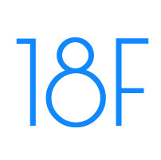

Request for Quotation (RFQ)

4QTFHS150004

SIN 132-51

General Services Administration (GSA) Federal Acquisition Service, Integrated Technology Service National IT Commodity Program

401 West Peachtree Street NW, Suite 820 Atlanta, GA 30308

**Created by:**



1900 Campus Commons Drive, Suite 150

Reston, Virginia 20191

703.581.6500

Rich Zimmerman

Contracts Manager

Defender System

Usability Test Report

2015

Table of Contents

1.0 Introduction 1

2.0 Tests Executed 2

2.1 Visibility of system status 2

2.2 Match between system and the real world 3

2.3 User control and freedom 4

2.4 Consistency and standards 5

2.5 Error prevention 6

2.6 Recognition rather than recall 7

2.7 Flexibility and efficiency of use 8

2.8 Aesthetic and minimalist design 9

2.9 Help recognize & recover from errors 10

2.10 Help and documentation 11

# Introduction

Usability Testing was performed by evaluating the Defender prototype against Nielsen’s 10 Usability Heuristics for User Interface Design (<http://www.nngroup.com/articles/ten-usability-heuristics/>). The site was evaluated against each of the 10 heuristics; results are detailed below.

The following definitions apply as it relates to severity rating:

0 = I don't agree that this is a usability problem at all

1 = Cosmetic problem only: need not be fixed unless extra time is available on project

2 = Minor usability problem: fixing this should be given low priority

3 = Major usability problem: important to fix, so should be given high priority

4 = Usability catastrophe: imperative to fix this before product can be released

# Tests Executed

# Visibility of system status

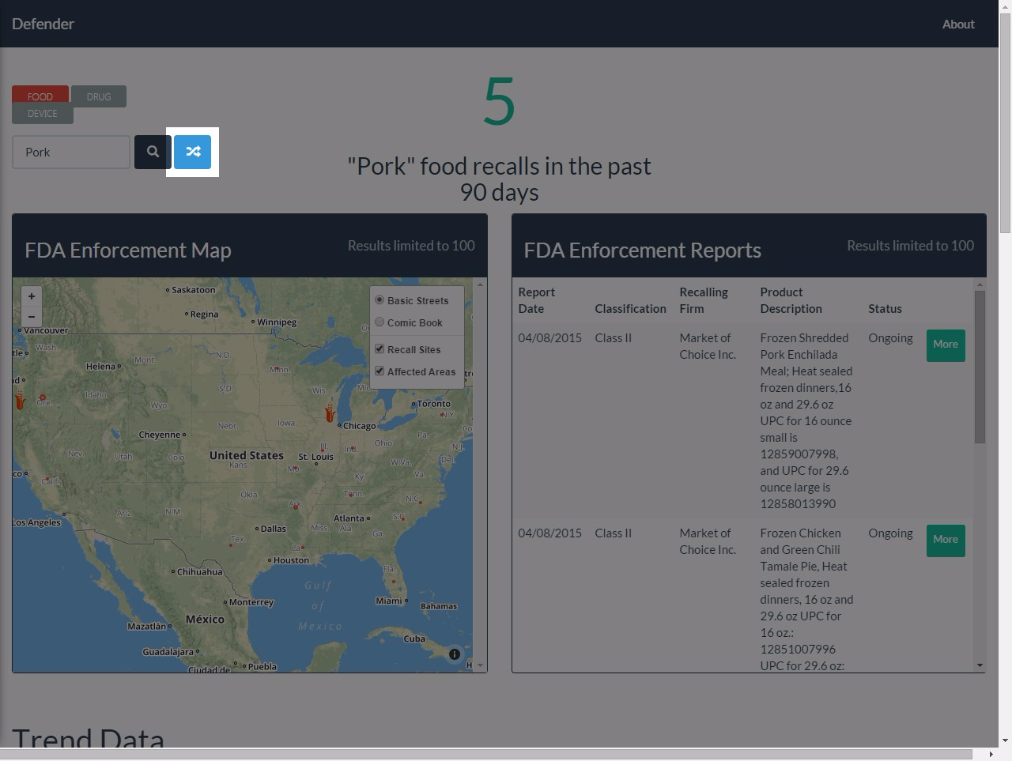

**Severity: 2**

**Notes:**

The initial load of the map takes a bit and can be a bit confusing if you are trying to refine your search criteria or navigate the map as it is loading. Once the initial page is loaded, the site is responsive and keeps the users aware.

**Recommendation:**

Improve performance of the initial load and/or give users a message indicating it is still loading

# Match between system and the real world

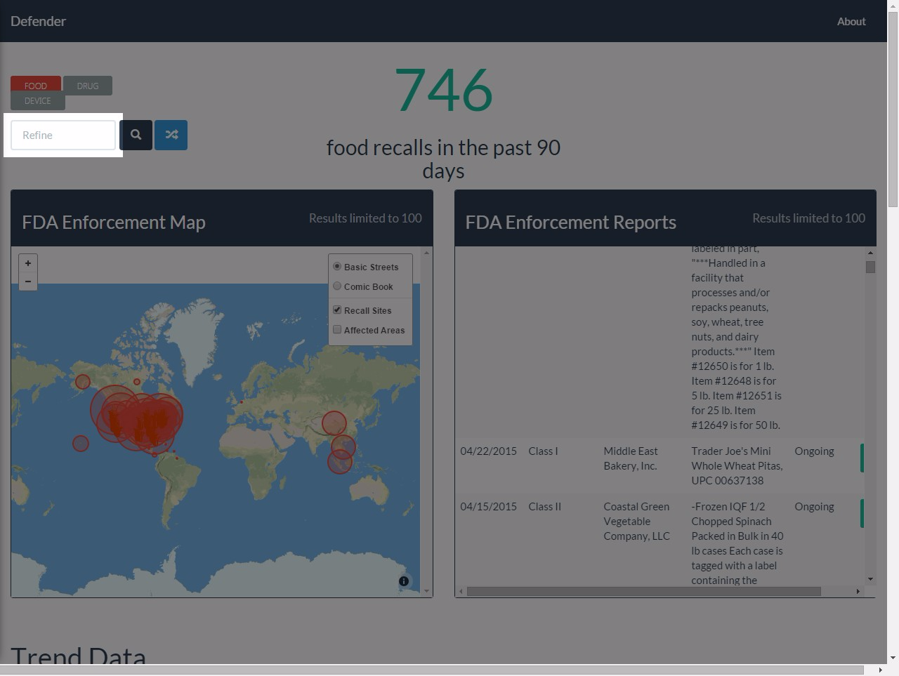

**Severity: 0**

**Notes:**

System uses basic words like food, drug, and device. Does not get into computer-speak.

**Recommendation:**

No further recommendations.

# User control and freedom

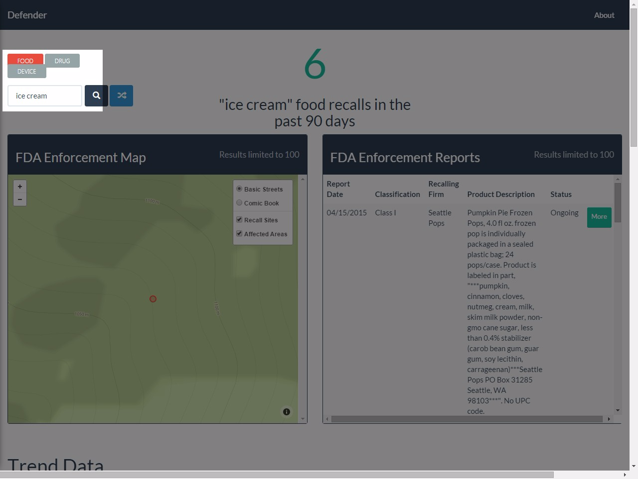

**Severity: 0**

**Notes:**

This is a single page site, with navigation enabled through vertical scroll, which is largely intuitive. There is no transactional behavior to the site so things like undo and redo are N/A.

**Recommendation:**

No further recommendations.

# Consistency and standards

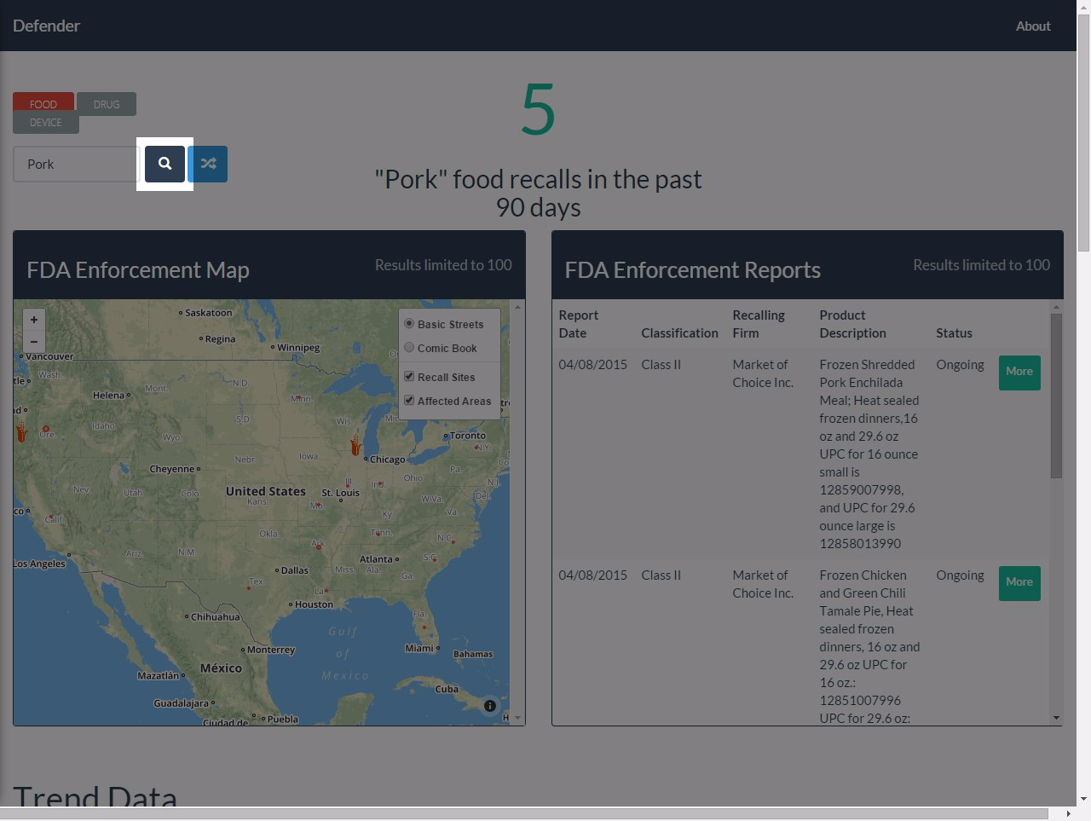

**Severity: 1**

**Notes:**

The site is consistent in the use of FDA Enforcement for the things being displayed from FDA. The matching of the terms food, drug, and device is consistent across search and the map display.

**Recommendation:**

It would be useful to clearly delineate that the top tiles are provided by FDA, while the bottom ones are provided from other sources.

# Error prevention

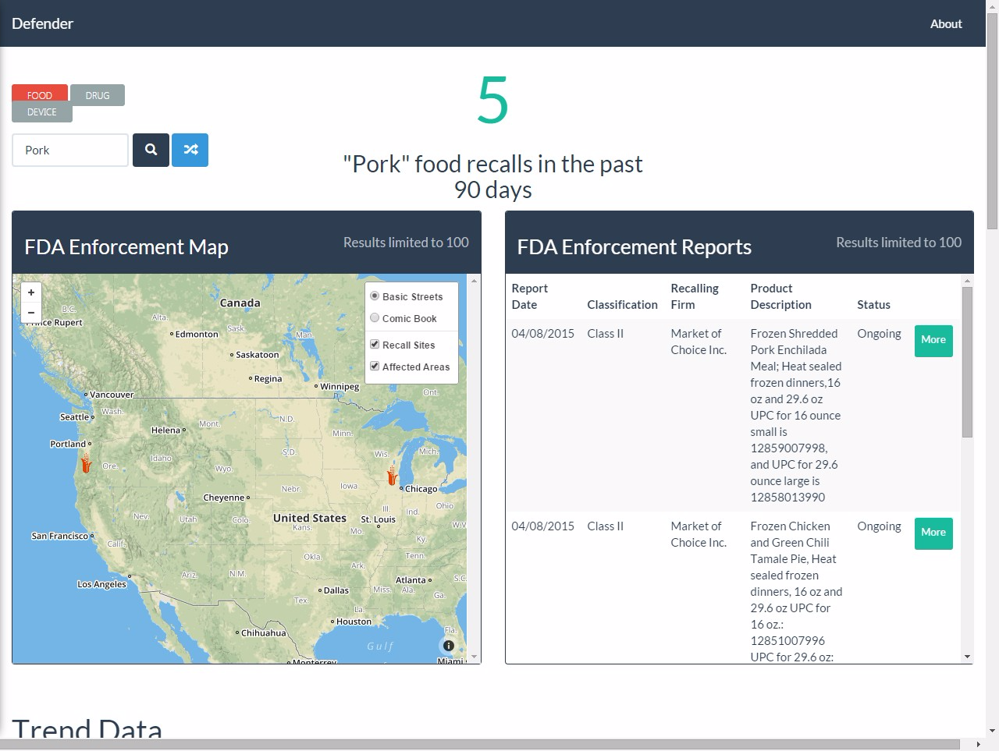

**Severity: 0**

**Notes:**

The site is not transactional so there are limited ways in which errors can be created. The results do explain if there isn't enough data for trending information.

**Recommendation:**

No further recommendations.

# Recognition rather than recall

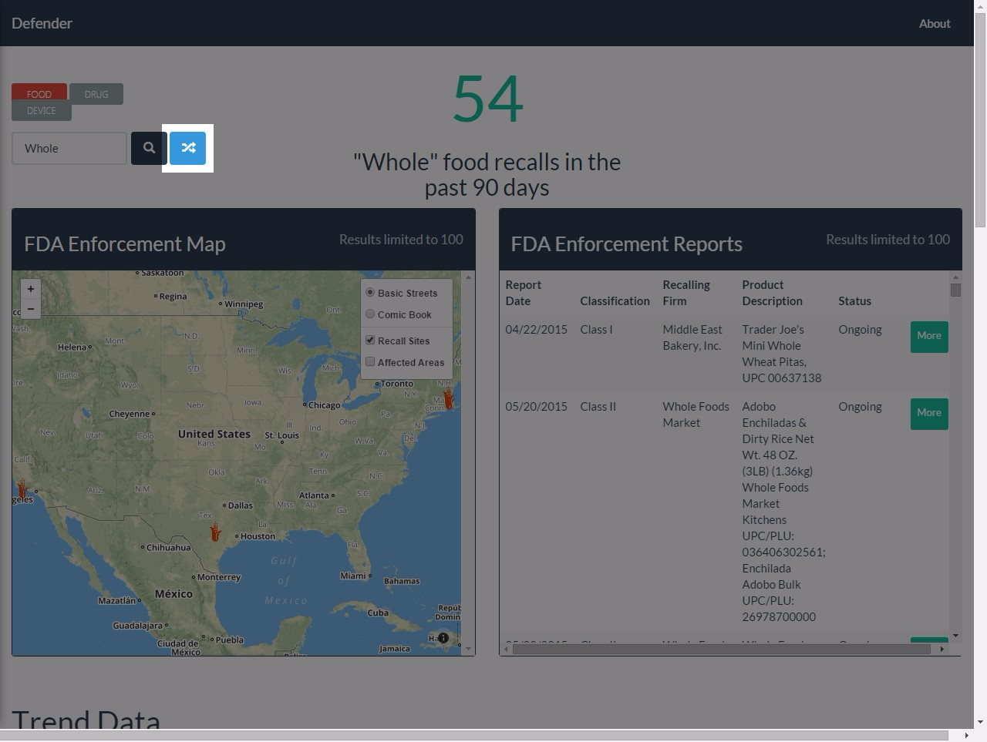

**Severity: 1**

**Notes:**

The main use of the site is recognizable upon load. Toggles between types of recalls and the refinement by search is intuitive. The ‘Surprise Me’ button is a nice feature but the icon is not immediately recognizable

**Recommendation:**

Look for a more intuitive 'Surprise Me' icon

# Flexibility and efficiency of use

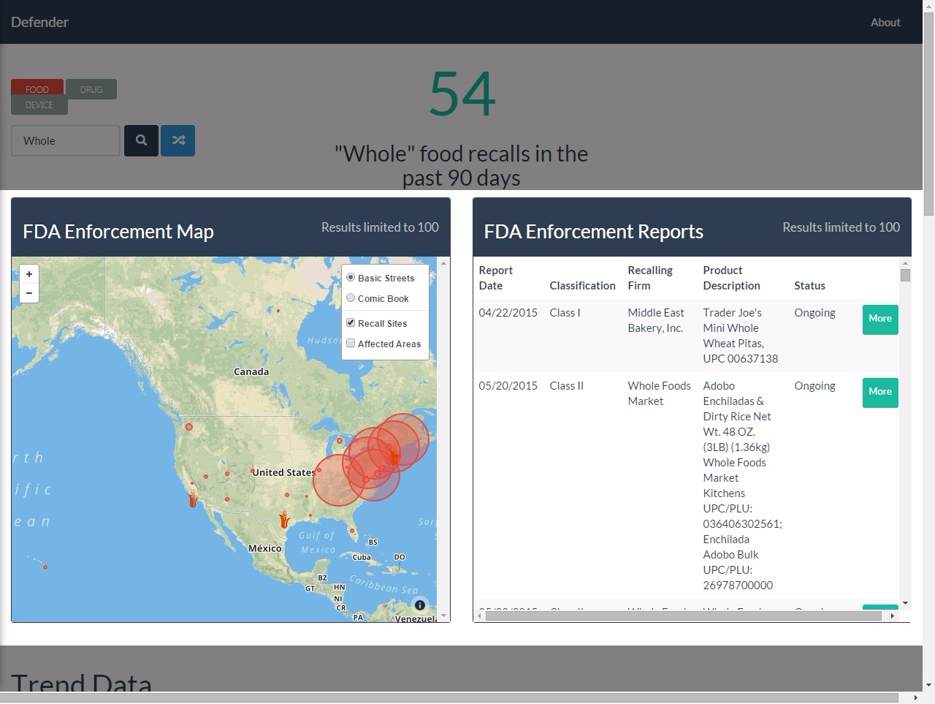

**Severity: 0**

**Notes:**

As a single page site based primarily on search, there are not many ways to accelerate navigation or frequent actions.

**Recommendation:**

No further recommendations.

# Aesthetic and minimalist design

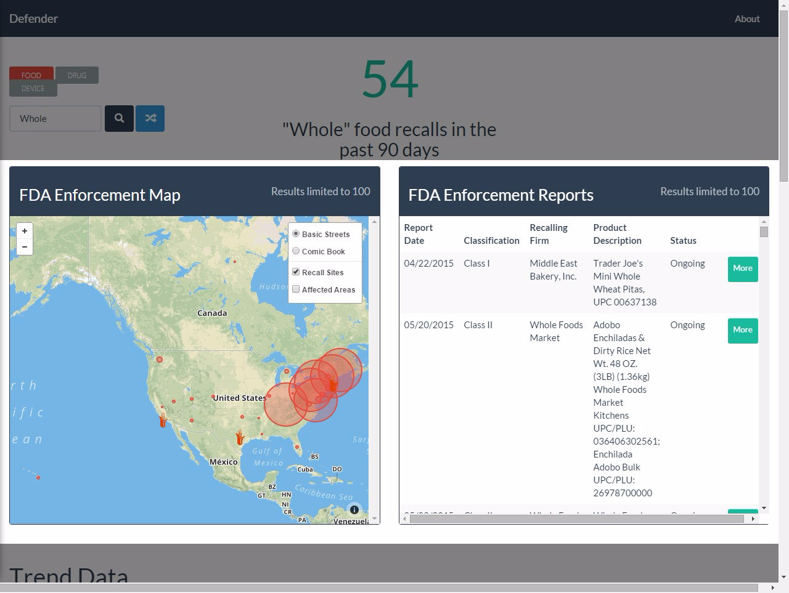

**Severity: 0**

**Notes:**

Very clean design. Muted colors and separation of types of data and display/visualization. Simple and appealing.

**Recommendation:**

No recommendation here.

# Help recognize & recover from errors

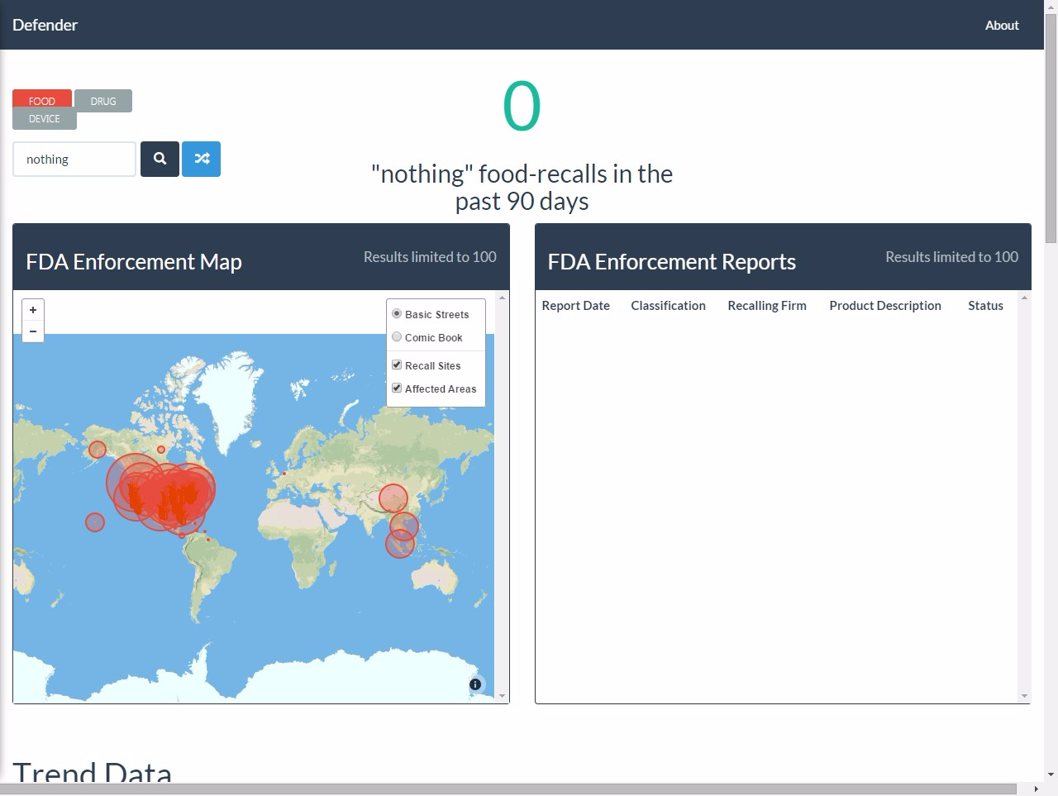

**Severity: 2**

**Notes:**

If the search returns nothing, the site tells the user that. However, the Reports window shows nothing and the map window doesn't clear itself.

**Recommendation:**

Add more cues to the user inside the individual panes as to the fact that there are no results; also reset the map to show nothing. Change the text at the top of the page to notify the user that no results were returned rather than displaying that a search for “nothing” was executed.

# Help and documentation

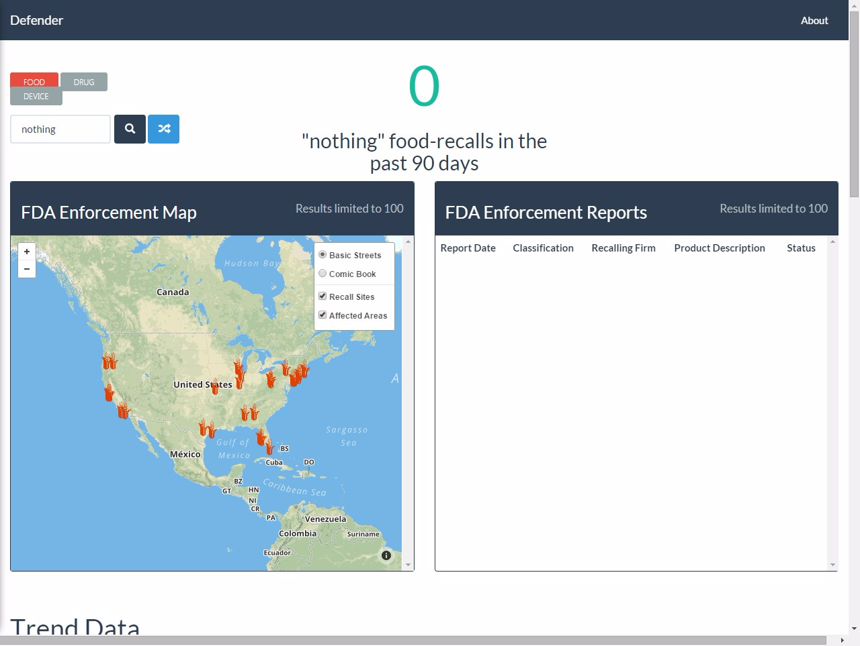

**Severity: 0**

**Notes:**

There is no help included; however, that is overkill for this site. There are intuitive controls for things like search, 'More', etc.

**Recommendation:**

No recommendations here.